JENKINS INSTALLATION AND LOGIN DOCUMENT:-

First we launch an instance successfully.

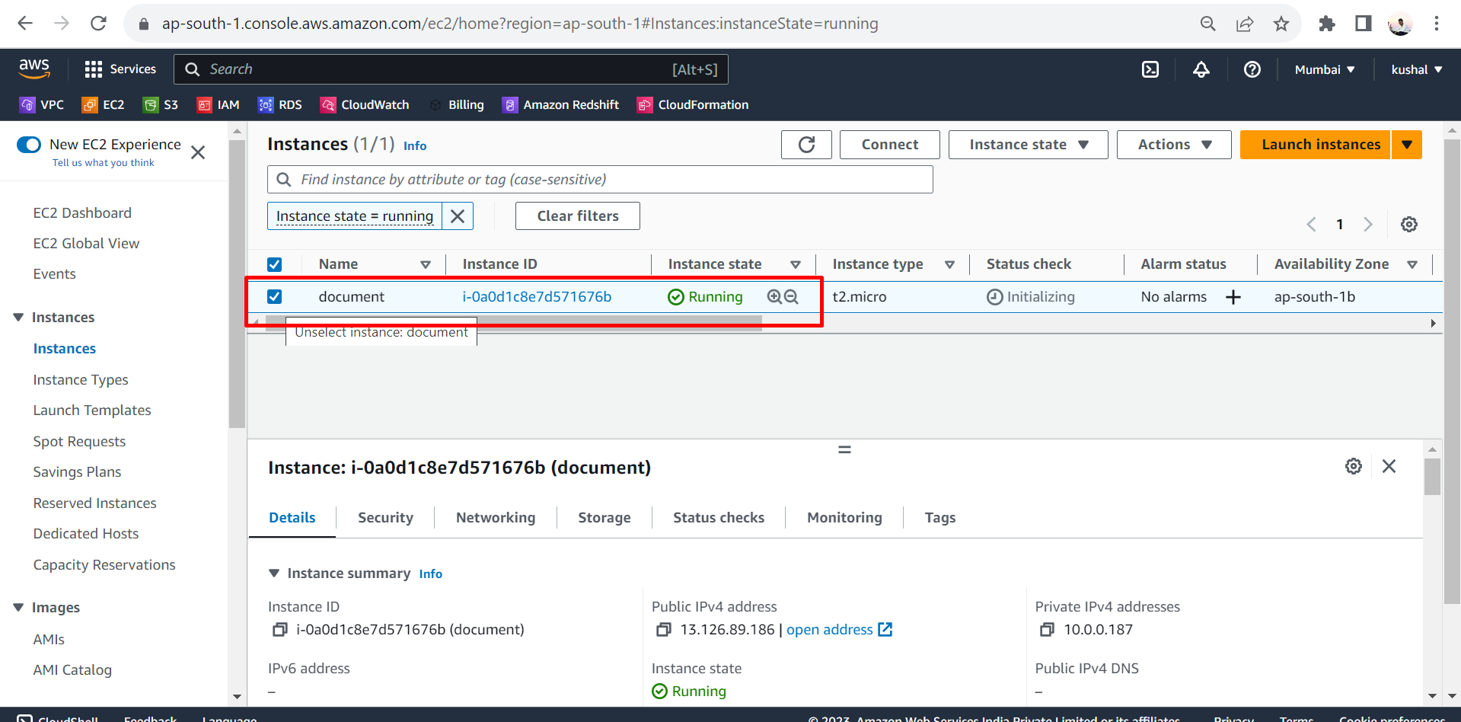

After that we connect that server with mobaxterm.

Connecting process:-

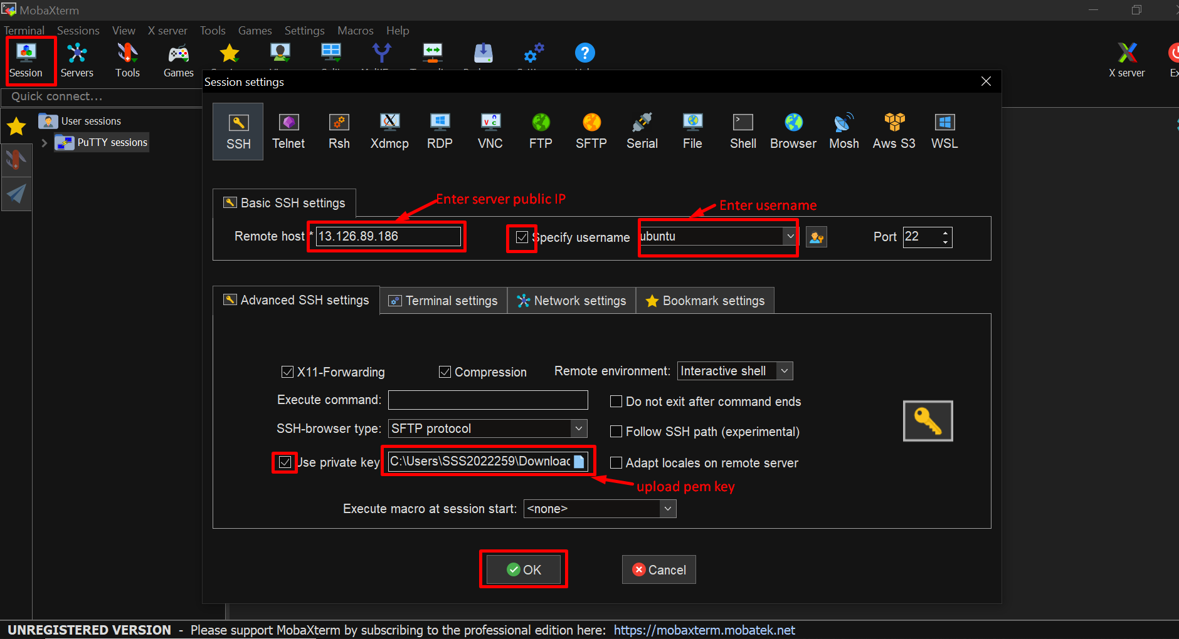

We connected Successfully.

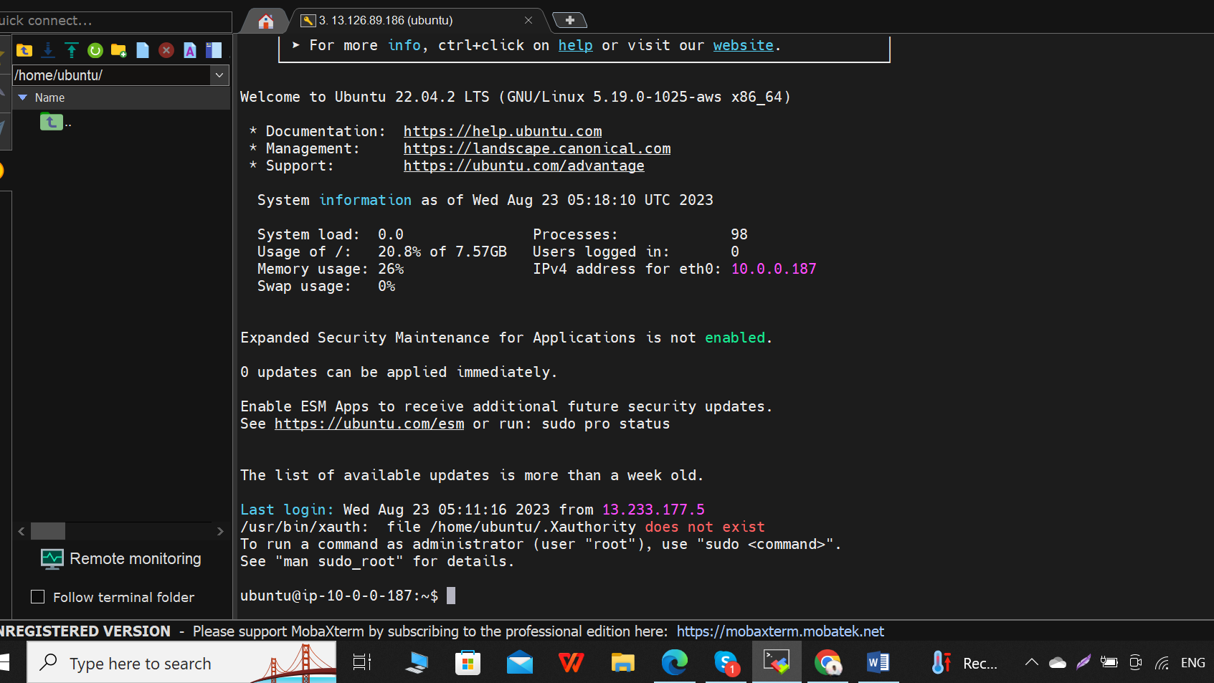

After that we use some commands for installing Jenkins in that server.

Commands:-

1. Sudo apt-get update ### to update

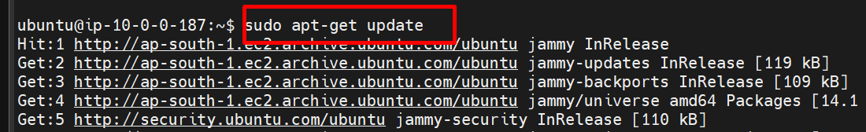

2. Sudo apt install openjdk-11-jdk –y ## installing java

3. Java –version # to check java is installing or not and check which type of version we installed.

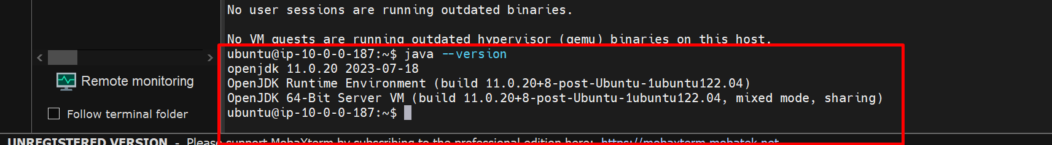

4. Wget -q -O - https://pkg.jenkins.io/debian/jenkins.io.key | sudo apt-key add –

5. sudo sh -c 'echo deb http://pkg.jenkins.io/debian-stable binary/ > /etc/apt/sources.list.d/jenkins.list'

6. sudo apt update

7. sudo apt install Jenkins –y

8. Jenkins – version ## to check version and installed properly.

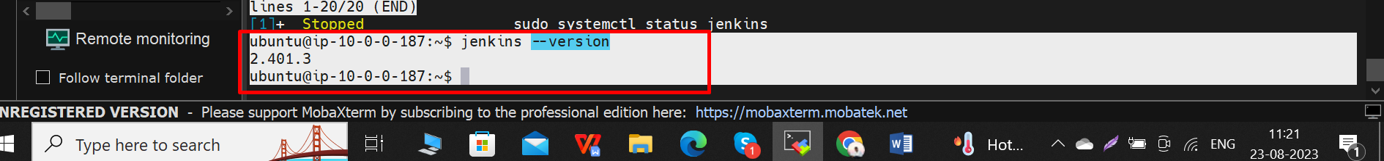

9. sudo systemctl start jenkins # to start the Jenkins

10. sudo systemctl status jenkins # to check status Jenkins.

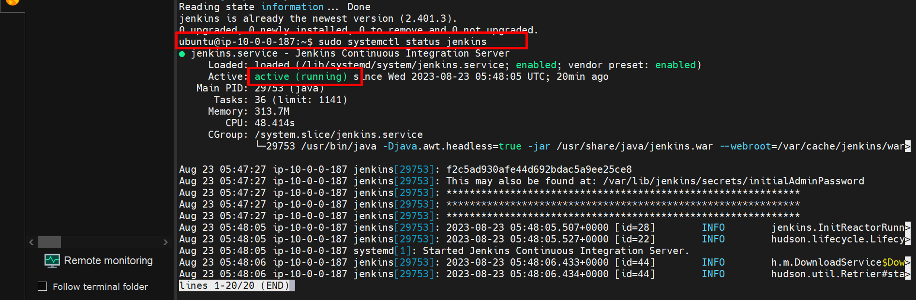

After that we enter public IP in search bar in browser with 8080 port

Example :- <http://localhost:8080/>

Here we had some problem the jenkins site not open because we do not add port 8080 in security groups.

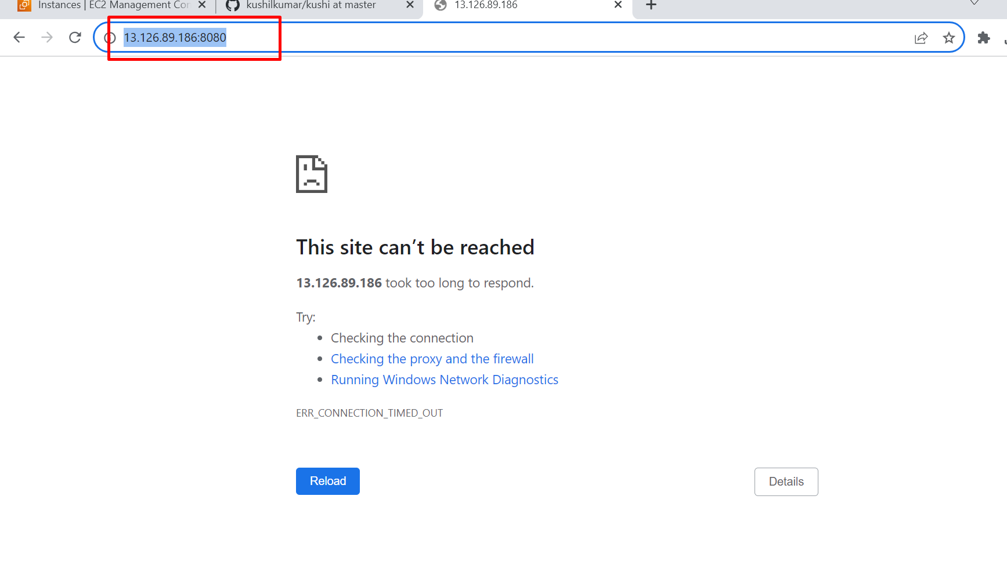

Then we must add port 8080 in security groups in this server.

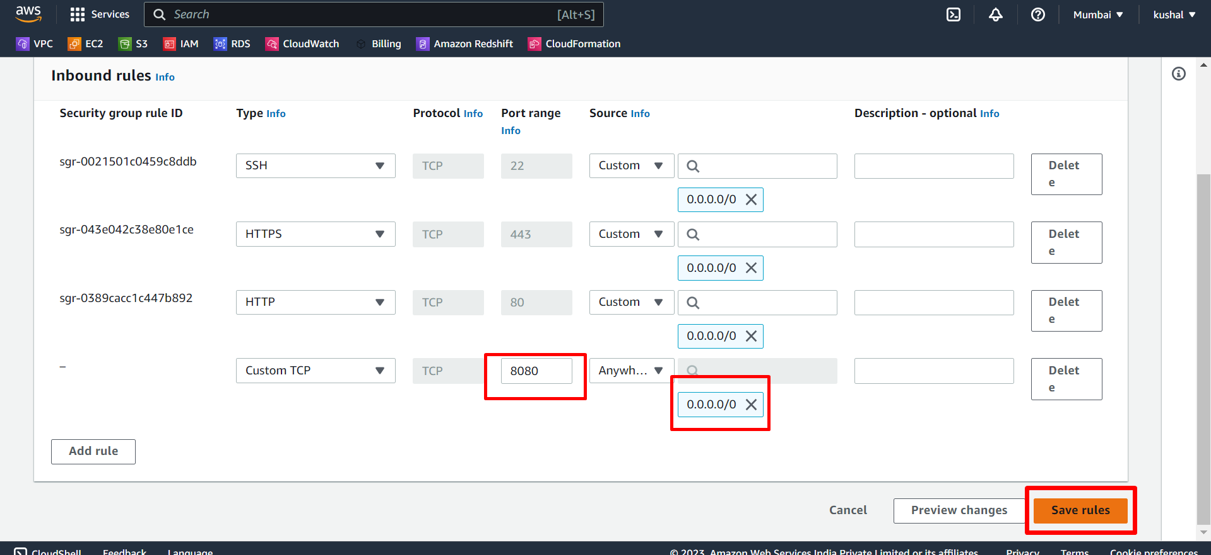

After add port 8080 and save that rules and refresh again in web browser it shows like this .

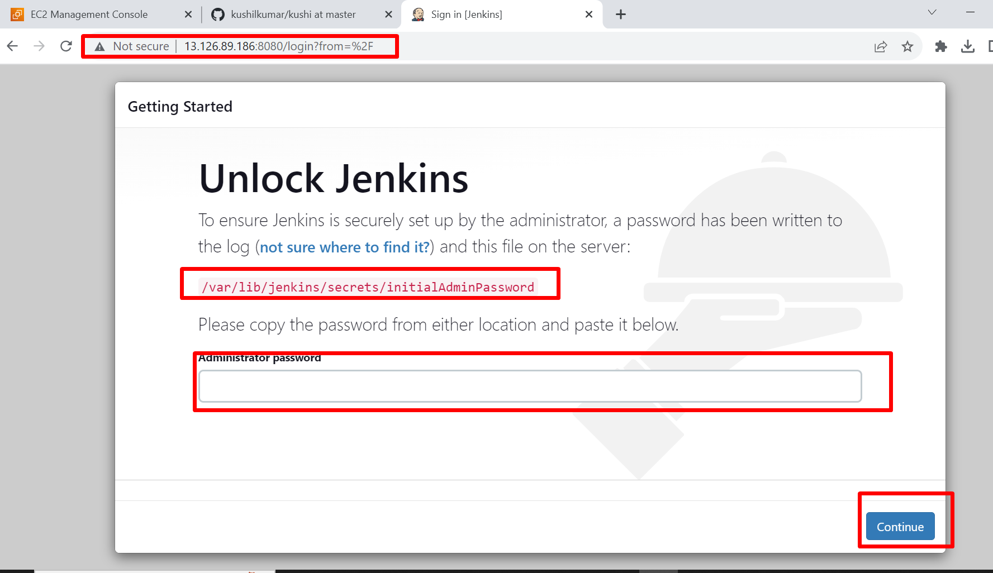

We need password for login in jenkins , this password are in this path



Now copy that password and paste in the jenkins web browser.

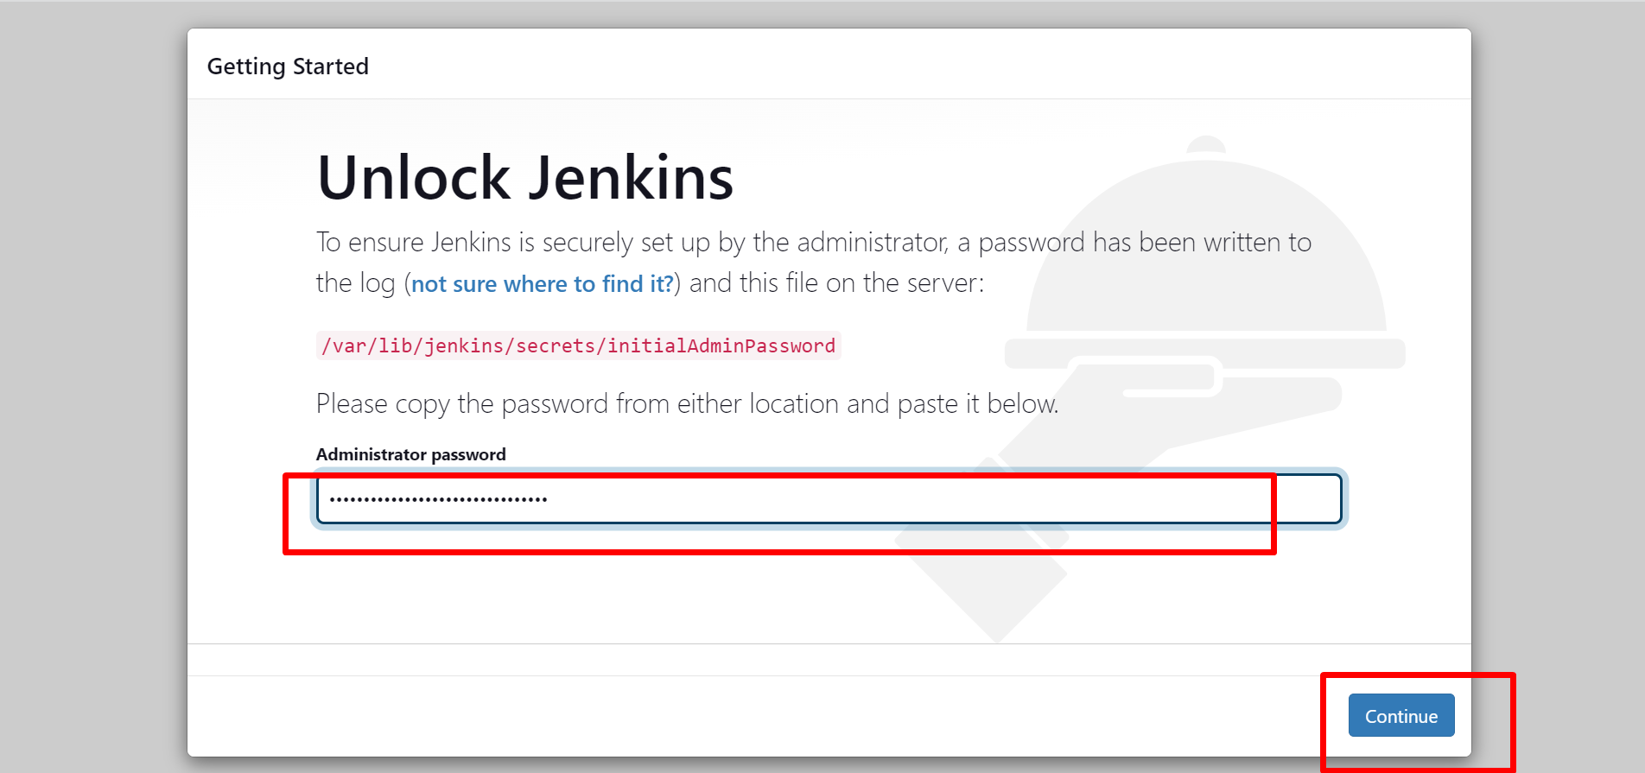

Next step click **on install suggested plugins.**

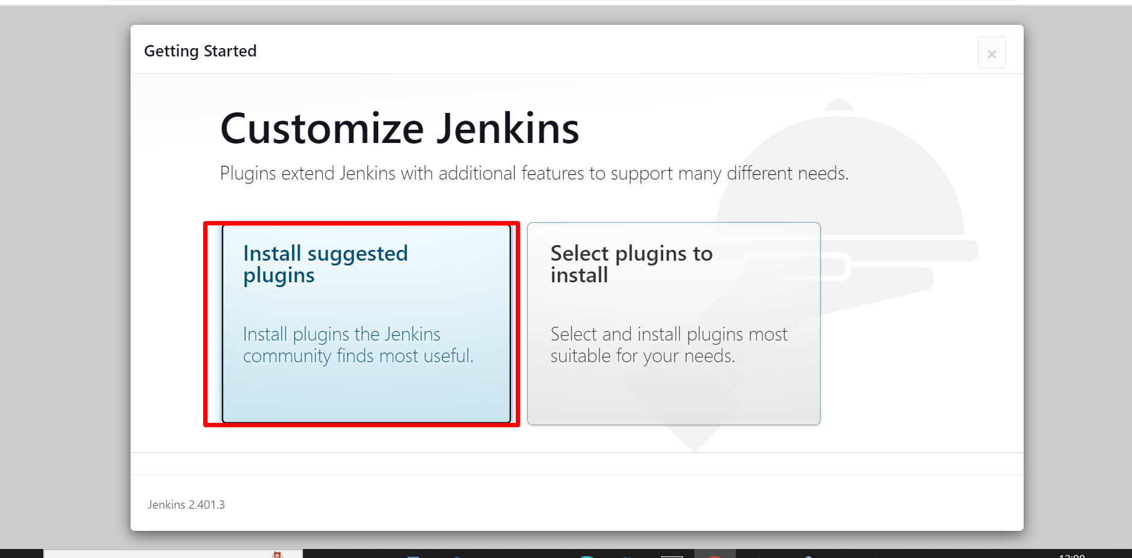

It take some time to install after that we create user name and password to login credentials.

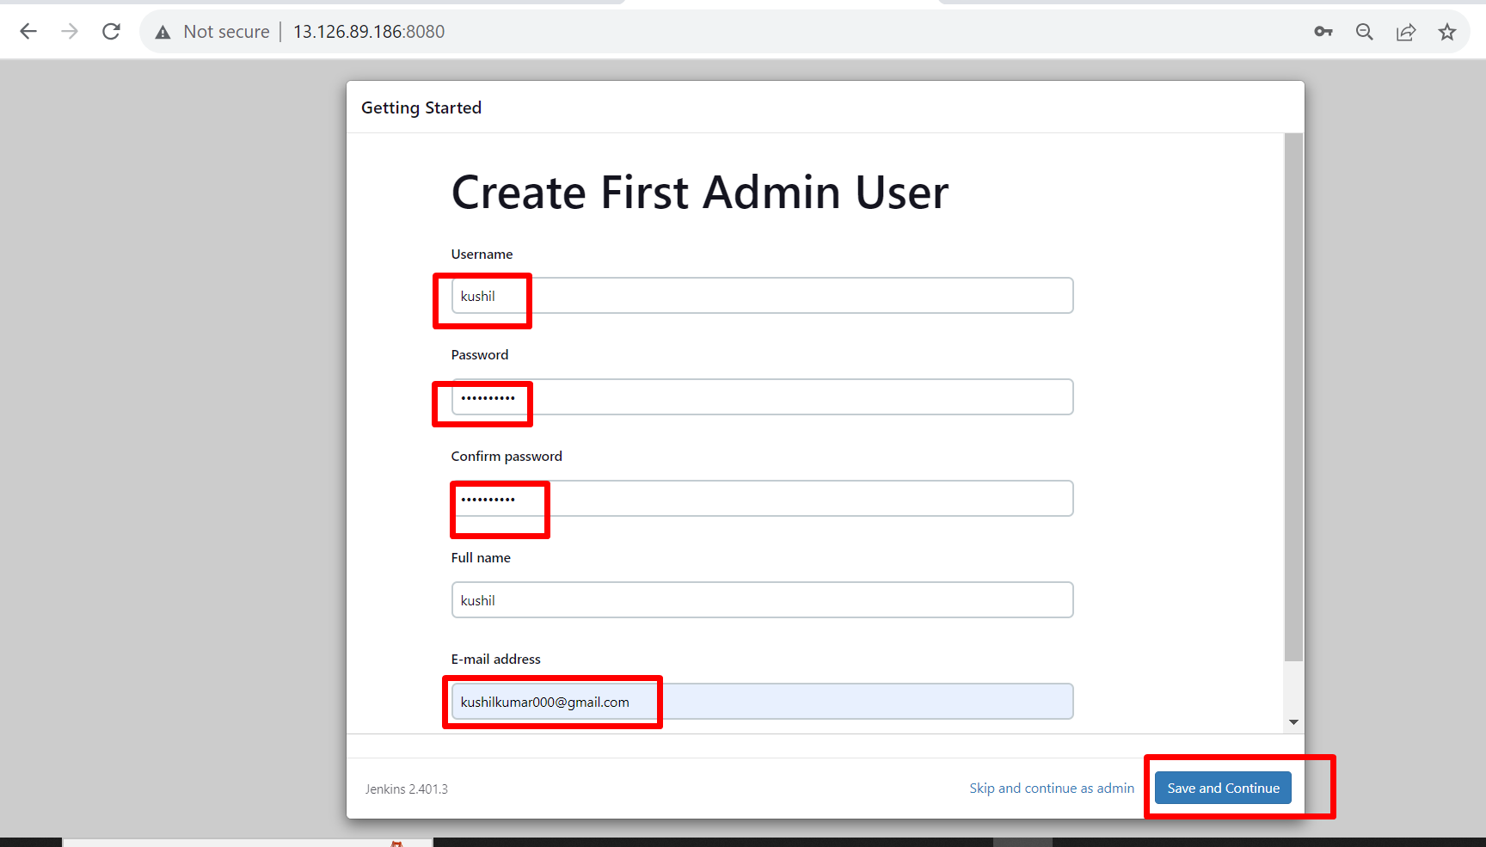

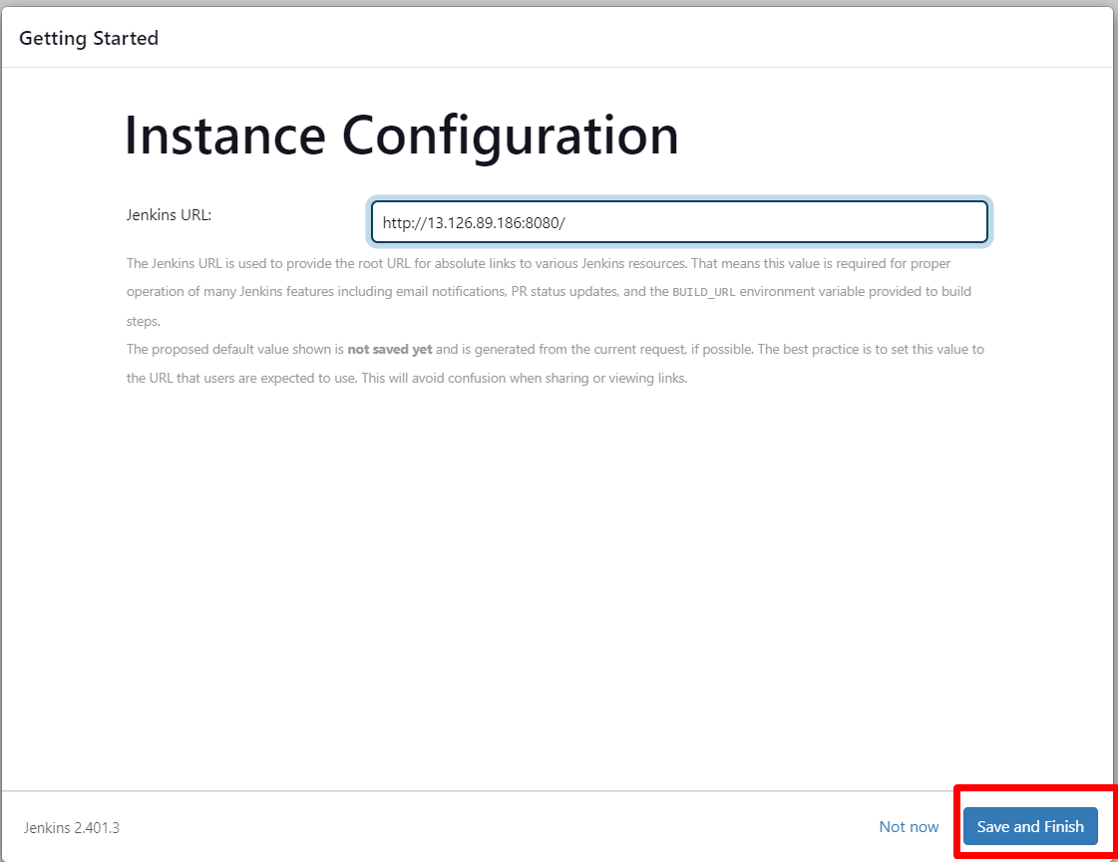

We successfully login in jenkins.

